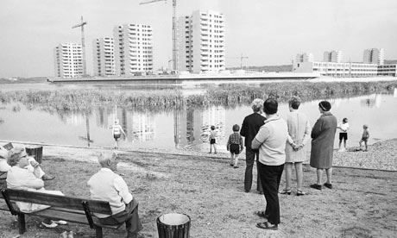
Community Building:
Workshops

10 & 17 May 2013
Bangor University

Registration Form

If you would like to attend, please complete the details below and return the form by 3rd May, 2013. You can email the form as an attachment to his401@bangor.ac.uk (with subject heading ‘Community Workshops’. Alternatively, please post the form to: Dr Dinah Evans, School of History, Welsh History & Archaeology, Bangor University, College Road, Bangor, Gwynedd, LL57 2DG.

I wish to attend (please tick those that apply):
Workshop 1: Community Building & Governance Friday 10 May 2013 
Workshop 2: Community Building & the Third Sector Friday 17 May 2013 

Your Details:
Title: |  |  |  |  | First Name: |  |  | Surname
Address:
 |  |  |  |  |  |  |  | Postcode:
Institutional Affiliation:
E-mail: |  |  |  |  |  |  |  | Tel. No.:

If you have any dietary or mobility requirements, please note them here:

I WILL NEED A PARKING PASS ON ARRIVAL: Yes / No

For further details contact: his401@bangor.ac.uk or his801@bangor.ac.uk

